Micah Patt

Advanced Tonal Analysis Final Paper

April 17th, 2023

Adam Guettel’s *The Light in the Piazza* is a 2003 musical that brings advanced compositional structures to a genre that is contemporarily saturated with “vibe” based sound. The libretto, written by playwright Craig Lucas, follows mother-daughter pair, Margaret and Clara, as they venture past their home in Winston-Salem, North Carolina to explore Florence, Italy for the first time. Guettel’s overarching theme in the musical is contrasting disjunct rhythms with sweeping romanticism. One of the most glaring examples is in Clara’s first solo song, “The Beauty Is.” In the piece, he highlights Clara’s chaotic mental state with her deep longing for connection. Guettel uses extended harmony, texture changes, and chromatic text painting to demonstrate the juxtaposition of instability and desire in Clara’s psyche.

Adam Guettel honors Clara’s arc with his compositional choices, many of which are inspired by his upbringing in the shadow of his grandfather, Richard Rogers, and his family friend, Stephen Sondheim. Jesse Green writes in a 2003 review of Guettel’s work that “The rhythmic inventiveness and restless harmonies are duly saluted [to Sondheim], but in the supple long lines of the gorgeous melodies, it’s Rogers you hear on top”.[1] In addition to his skill as a composer, Guettel played classical and jazz piano, as well as guitar and upright bass in rock bands throughout his youth. Guettel considers himself a “method composer” in that he puts himself in the headspace of the characters he is writing for, which may be one reason for his detailed characterization of Clara.[2]

“The Beauty Is” is prompted by Clara’s viewing of a naked statue in an art museum in Italy. Immediately after the song, Clara’s hat flies off and is intercepted by a young Italian man, Fabrizio. Clara and Fabrizio share a spark based on their shared child-like wonder and fascination with the world around them. Margaret, seeing their connection, shuts down their flirtation out of concern for her daughter’s wellbeing. Clara has always been reliant on her mother as a caretaker. Despite Margaret’s protestation, Fabrizio and Clara continue to meet, and their initial infatuation develops into love. Fabrizio’s family is enamored with Clara, but Margaret is apprehensive of their relationship. She does not want to reveal that when Clara was twelve, she was kicked in the face by a pony, which left her with substantial brain damage and the emotional maturity of a young girl. Because of this, Margaret is protective of her daughter, and is as reliant on Clara as Clara is on her. After Clara demonstrates her maturity and groundedness in singing her Act II solo, “The Light in the Piazza” in which she likens the concept of light to the feeling of being in love (Fabrizio even calls her “my light”), Margaret concedes to the pair’s relationship. Clara and Fabrizio ultimately get married and live happily in Italy with one another.

**Harmony**

“The Beauty Is” is one of the most beloved contemporary “legit” soprano songs in the musical theatre canon, but it is unfortunately known as a song that performers shouldn’t bring into the audition room because of the level of difficulty of the piano line. The piece is characterized by its jolting rhythmic pattern in the G section and the contrasting romanticism in the section marked as A♭**.** Guettel’s primary compositional motives in this piece include: extended harmony, an added sixth, modal mixture, chromatic mediant, and incessant rhythmic figures. All of these strategies build upon the dramatic connection to Clara’s instability and romanticism.

“The Beauty Is” begins with a six measure piano introduction. In the first two measures, the piano abruptly throws the listener off balance with cross relations and modal mixture. There is something happening on every sixteenth note of every measure of the introduction, creating an angular rhythmic pattern. The first measure includes a G7 chord, which is the I chord since the piece begins in G major, but there is an added E, which is the sixth scale degree, in the bass clef. The core of the chord contains the G in the bassline and the B and D in the right hand. The quality of the G7 chord switches between dominant and major with the F**♯**4followed immediately by an F♮5. Placing two different versions of the same note in different voices results in a jarring experience for the listener. The second measure maintains the bizarre rhythmic pattern, but flattens the B and E, making it a G minor 7 chord with a flat 6, or a minor i chord. From a neo-Riemannian lens, this is a parallel transformation. One could interpret the G minor chord as an E**♭** 9 chord, but given that the foundation in the bassline is still G and that Guettel uses neo-Riemannian transformations elsewhere in the piece, G minor makes the most sense. The mix between the parallel major and minor is an idea Guettel plays with again in the A♭ section.

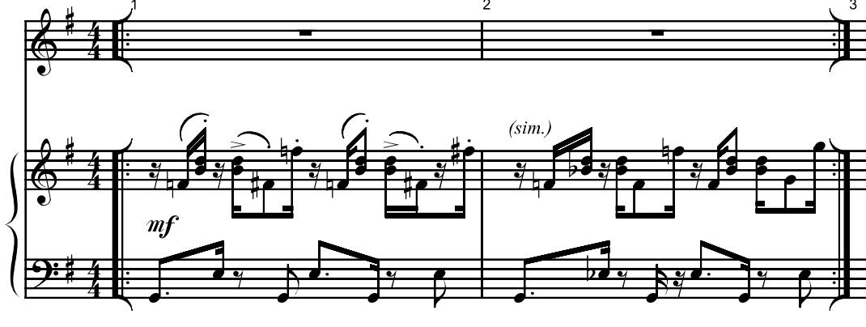

Fig. A, mm. 1-2.

In measures 1 and 2, the same chord is outlined for each measure’s entirety, but in measure 3, the harmonic rhythm doubles in speed, reflecting Clara’s racing thoughts and increased excitability. The piano rushes towards measure 4, where Guettel finally moves the harmony from ping-ponging back and forth between G major and minor to a B♭ major 7 chord, while still including the added sixth scale degree. Prior to this shift, Guettel uses parallel neo-Riemannian transformations to move between the parallel keys of G major and minor, however in the move to B♭ major 7, he uses a the relative transformation. Using roman numeral analysis, this brings the harmony to a major III chord in the key of G major. Considering that G and B♭ are a third apart and the chords are both the same quality, this could be interpreted as a chromatic mediant. Measure 4 feels like a new idea. Clara’s mind is wandering and racing off to so many places. The resulting sound of the piano introduction is jaunty, but also mildly upsetting. Audiences get the first glimpse into Clara’s mind, prompted by her seeing a naked statue for the first time. Guettel’s choices here could be representative of all of the neurons firing off in Clara’s brain as she has a new experience. At this beginning stage of the musical, audiences don’t know that Clara’s mind doesn’t work the same way as others’, so the music foreshadows her condition.

During Clara’s first lines of text, the piano repeats its harmonic pattern of neo-Riemannian transformations between parallel and relative, before moving to the V7 chord of G major, D (with an added ninth and eleventh). The move from B♭ major 7 to D7 is an LP (leading tone, parallel) transformation, and leads audiences to expect a cadence in G major, but Guettel instead surprises listeners with another LP transformation to F♯7, the dominant of the new key, B major. The unexpected motion makes tracks with Clara’s sudden mood shifts and fervorous moments. Guettel uses parsimonious voice leading to track between the key areas. F♯/G♭ carry over as the common tone between the two chords, and the G♯ in the D7 acts as a preview of the added sixth scale degree of the soon-to-be key.

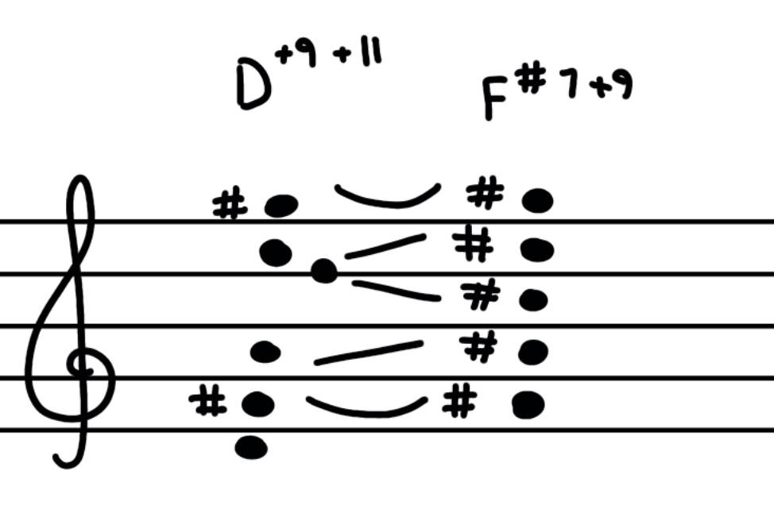

Fig. B, mm. 9-10 voice leading.

In the first twelve measures of “The Beauty Is”, Guettel explores several key areas using increasingly complex neo-Riemannian transformations. In the introduction, and when Clara begins her melody, he uses only simple parallel and relative transformations, but when she ventures out and gets herself wound up, the transformations become twice as long to travel. Although they key areas technically are an RP transformation apart, Guettel makes the journey to get there complicated (G major to G minor to B♭ major to D major to F♯ major, and finally to B major). Emotions that may be simple for others take Clara a long way to process, which is reflected in the harmony. Guettel may also be highlighting the simultaneous simplicity and complexity of romantic love. The tonnetz below shows the transformations in the first section of the piece with measure numbers notated.

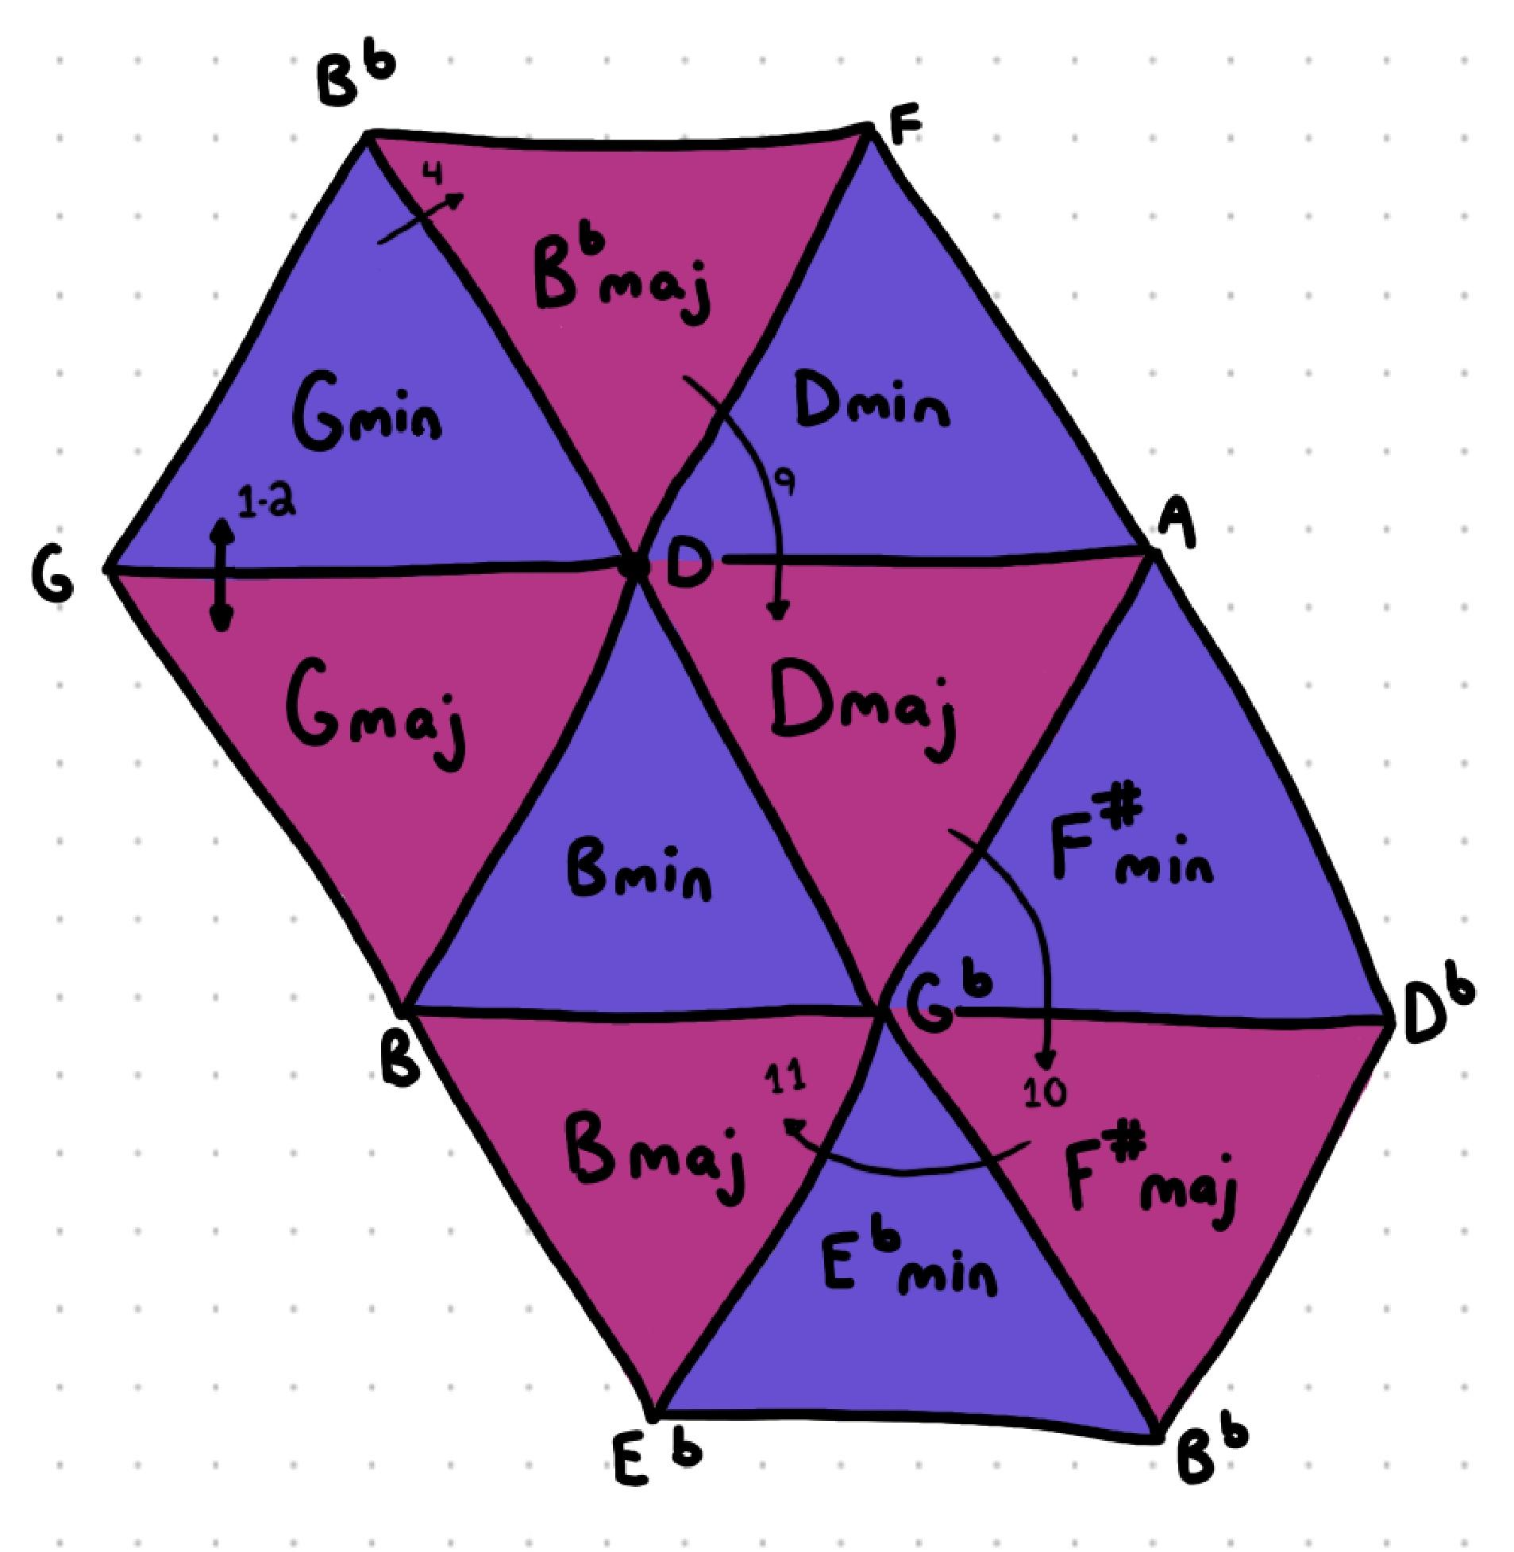

Fig. C, Tonnetz of mm. 1-12

Guettel ventures even further away from the initial key area of G major in the second section of the piece, where he shifts the key signature from B major through an RP (relative, parallel) transformation to A♭ major, but the vocal line quickly moves back to A♭ minor, which reflects the dramatic content of the text, as Clara says “I’m just a someone in an old museum, far away from home as someone can go, and the beauty is I still meet people I know.” The shift back to A♭ minor, which is closer on the tonnetz to the original key of G major, reflects Clara’s idea that she is emotionally closer to home than she physically seems. The RP transformation again uses the same voice leading that Guettel employs in the first key shift from G major to B major. There is a constant B/C♭ hidden between measures 12 and 13, which is the constant between the two key areas, and all of the other pitches shift chromatically.

Before landing on A**♭** minor in measure 15, the left hand of the piano outlines an F diminished triad over A**♭**, which again highlights the relationship of a sixth between A**♭** and F. While the sixths have been hidden within larger chord clusters in the G major section, at the start of the texturally calmer portion at measure 13, the sixth is brought out. Maybe the sixth represents Clara’s desires that underlie the chaotic surface of her brain. Guettel continues his use of extended chords despite the deceptive dramatic rhythmic change in the piano. The rhythmic shift seems like Clara is attempting to find stability. “And the beauty is, I still meet people I know,” indicates that she is finding a way to be comfortable even with all of the exciting new things surrounding her.

The second texture change occurs in measure 22, where the piano shifts from sparse with creeping bass lines to “boom-chuck” block chords with creeping bass lines. Starting at measure 22, the tenor line in the piano descends from G**♭** to D, and the voice has a scalar sequence that descends centered around A**♭.** Despite the apparent calmer harmony, there is no functional root of the chords in measures 22-30. Rather than giving each of these chords names, one could analyze this whole section as a large-scale chromatic voice-leading. Mm. 22-30 is where audiences hear the essence of Richard Rogers in Clara’s melody, and Guettel pares back the piano to let her voice shine. In mm. 31, there is a brief return to the second textural section, before skipping back to the beginning in G major in measure 38. The lead-up to the return to G major includes a B**♭**major chord, which is a major II chord in A**♭** major and a flat III chord in G major, which is the same chromatic mediant lead up to Clara’s first text at the beginning of the piece. There is also an arpeggiated Dm/F chord immediately before the I chord of G major in measure 38, which is the minor dominant of the key Guettel is moving to.

Starting at measure 38, the same harmonic pattern repeats until mm. 46, where the transition from B major to A♭major includes an octatonic scale in the piano line, starting with an E♮ in the bassline, and ultimately outlining an E♭7 scale. Considering neo-Riemannian transformations in this passage, the E**♭** chordacts as a transition between an LP and LR transformations. This is a longer pathway than the first transition to the A♭ key area.

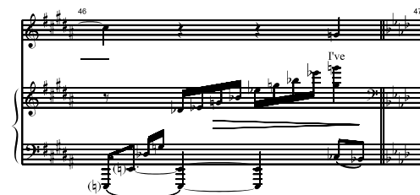

Fig. D, mm. 46, octatonicism in the piano line.

Guettel and Sondheim were family friends and Guettel takes inspiration from his compositions. Stephen Sondheim uses octatonic scales in the musical “Into the Woods” to represent curiosity/wonder. An example of this is in “Giants in the Sky” when Jack sings “The world you know begins to grow”.[3]

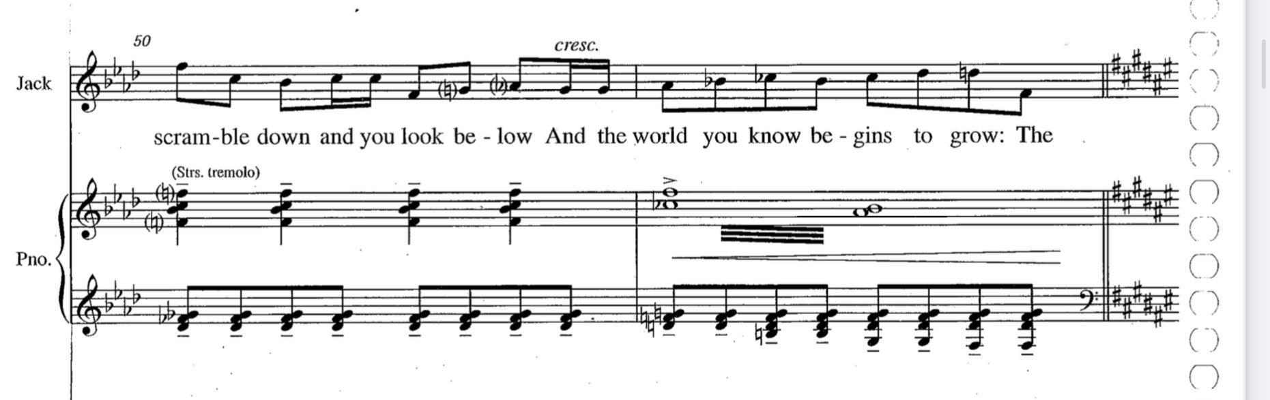

Fig. E, “Giants in the Sky,” mm. 51[4]

Similarly to Jack, Clara is experiencing a moment of discovery here, with the text expressing “I’ve hardly met a single soul, but I am not alone. I feel known.” It is possible that the octatonicism towards Clara’s realization that she is not alone is a reference to his mentor (“No One is Alone” is a core moral of *Into the Woods*).

The final chord of the piece is E**♭** 9 which is the vi chord of G major, further emphasizing the E and E**♭** hidden in the first two measures of the piece and the importance of the sixth scale degree. What Clara needs has been there all along, it’s just hidden within the chaos of her brain. The harmony in “The Beauty Is” is intricate and representative of Clara’s psychological state both in her mental condition and in her spontaneous discovery. Extended harmony, increasingly distant neo-Riemannian transformations, and added sixth scale degrees contribute to the big picture of her character and journey away from home.

**Text Painting**

In addition to his harmonic and textural decisions, Guettel uses text painting to communicate Clara’s state. When the vocal line enters in measure 5, it is simple and diatonic in G major, with the pattern “mi sol mi re re do do”, showing Clara’s child-like curiosity. Her melody varies with a flat 3 and 6 scale degree when she says “in Italy” in measure 6, which begins Guettel’s association of unfamiliarity in dramatic content with unfamiliarity in harmonic content. He repeats this concept again in the following measure, mm. 7 with a B♭ on the word “naked”.

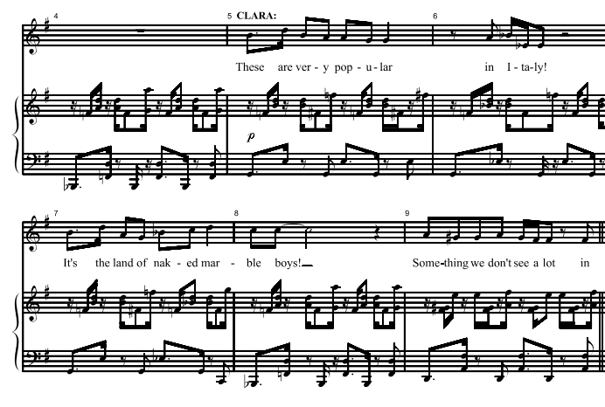

Fig. G, mm. 5-6, chromatic text painting.

Another notable quality of the vocal line is the relationship between the voice and piano. The melody latches on to little segments of the piano, but is generally much simpler. The initial dotted eighth and sixteenth notes are the same in “these are” and ‘It’s the”. It feels like Clara’s thoughts are moving too quickly for her speech to keep up.

After transitioning to A**♭** major, Guettel continues with text painting. Once the voice joins back in at measure 12, there are added accidentals of G**♭**, C**♭**, and F**♭,** which make the section in the parallel minor of A**♭** minor. Clara’s melody continues to be diatonic and simple, contrasting scalar passages with large, dramatic leaps. These contrasts depict Clara as unstable. Guettel uses more text painting on Clara’s line “far away from home as someone can go” (mm 17-18) as the interval increases E♭ to A♭ versus E♭ to B♭. The distance shows Clara’s increasing distance from her home in Winston-Salem, North Carolina. In measure 23 for the “refrain”, there is rhythmic stability in both the piano and in Clara’s line, and melodically, she has ditched the jarring leaps in favor of a lovely scalar sequence. She’s entirely diatonic in Ab maj, with the exception of the Cb in measure 28 on “almost,” mirroring her “almost” being in the major key. She returns to the parallel minor in measure 31.

An additional example of text painting in Clara’s vocal line is in the final phrase. There is an ascending sequence that moves the emphasis from E**♭** to G, and then descends back to E**♭.** The ascending sequence mirrors her descending sequence when she describes what she wants, but in her realization, she ascends instead. There may also be significance to the E**♭** on the text “and the beauty is” and “like you”. *The beauty is you, Clara.* That is the moral of the song.

Guettel’s harmonic, melodic, and rhythmic choices in “The Beauty Is” tell the audience everything they need to know about Clara’s character within her first few minutes onstage. His union of jazz harmonies with Golden Age theatrical melodies result in a confusing, but rewarding piece for the pianist, singer, and audience.

Bibliography

Green, Jesse. “A Complicated Gift.” *The New York Times*. Jul 6, 2003.

Guettel, Adam. “The Beauty Is.” *The Light in the Piazza*. Music Theatre International: 2005.

Hillard, Peter. “The Light in the Piazza: A Rough Guide for the M.D. Part 1: Landmarks of

Guettel’s style.” Jul 15, 2014.

[https://peterhilliard.wordpress.com/2014/07/15/the-light-in-the-piazza](https://peterhilliard.wordpress.com/2014/07/15/the-light-in-the-piazza-a-rough-guide-for-the-m-d-part-1-landmarks-of-guettels-style/).

Hoffman, William M.. “Conversations with William M. Hoffman: Adam Guettel, ‘Light in the

Piazza’.” *CUNY TV*. Jan 15, 2014.

<https://www.youtube.com/watch?v=Ibnoy_UsoLQ&t=418s>.

Sondeheim, Stephen and James Lapine. “Giants in the Sky.” *Into the Woods*. Ritling Music, Inc.

1987.

“The Art of Songwriting with Stephen Sondheim and Adam Guettel.” *Dramatists Guild*

*Foundation*. Apr 28, 2020. <https://www.youtube.com/watch?v=TofC3KD-h8M>.

1. Jesse Green, “A Complicated Gift,” *The New York Times*, Jul 6, 2003.
2. Ibid.
3. Peter Hillard, “The Light in the Piazza: A Rough Guide for the M.D. Part 1: Landmarks of Guettel’s style,” Jul 15, 2014, <https://peterhilliard.wordpress.com/2014/07/15/the-light-in-the-piazza-a-rough-guide-for-the-m-d-part-1-landmarks-of-guettels-style/>.
4. Stephen Sondheim and James Lapine, “Giants in the Sky,” *Into the Woods*. Ritling Music Inc., 1987.